SINGAPORE – BAX

Hospital Inventory Management System
( HIMS )

Functional Specification
Version 1.1

Prepared by:

Mano

&
For internal use only

Table of Contents

Revision History 5
Document Review and Approval 6
Introduction 7
Abbreviations 7
HIMS Model 8
HIMS Functions 12
1. HIMS Web Application 13
1.1 Admin 13
1.2 Masters maintanence screens 13
1.3 Receiving 14
1.4 Cycle Count management 15
1.5 AuditTrail/Security 16
1.6 Reports 16
1.7 Billing 18
2 PDA Module 18
2.1 Admin 18
2.2 Masters download 18
2.2.1 SKU 19
2.2.2 Inventory 20
2.2.3 Location details 20
2.2.4 PAR level 20
2.2.5 DODetail 21
2.3 Cycle Count 21
2.4 Replenishment ( TopUp ) 21
2.5 Data Upload 22
2.6 DO Confirmation 22
2.7 WareHouse Receipt 22
3. Exceed Configurations 23
4. Replenishment 24
5. Billing 24
6. Messaging 25
6.1 BBRaun to BAX 25
6.1.1 SKU 25
6.1.2 HospitalItemCodes 25
6.1.3 Transfer Ticket 26
6.1.4 Min/Max Level 26
6.1.5 Price Lists ( if required ) 26
6.1.6 LocationCodes/Clinic codes 26
6. 2 BAX --> BBraun 26
6.2.1 Consumption List 26
6.2.2 DO 27
6.2.3 Inventory Balance 27
6.2.4 BAX Replenishment Order 27
6.3.1 Consumption List 27
6.3.2 Inventory balance 28
6.3.3 TopUp info 28
6.4 Hospital → BAX ( ? ) 28
6.4.1 PAR level 28
6.4.2 ItemCodes 28
7. Assumptions 28
8 References 29
9 Table Schema 30
9.1 Table structures 31
9.1.1 HIMS_CycleCountApprovalDetail 33
9.1.2 HIMS_CycleCountDetail 33
9.1.3 HIMS_HospitalItemCode 34
9.1.4 HIMS_Inventory 34
9.1.5 HIMS_Locations 34
9.1. 34
6 HIMS_PARLevel 34
9.1.7 HIMS_PutAwayDetails 35
9.1.8 HIMS_ReceiptMaster 35
9.1.9 HIMS_Repl_Detail 36

Revision History

Date | Version # | Comments
9 Feb 2004 | Version 1.0 | Initial Draft
29 Feb 2004 | Version 1.1 | Assumptions corrected as per Doreen’s inputs on 24/02/04

Document Review and Approval

BAX Review List
Name | Title | Signature/Date

Introduction
This document defines the main functionalities that would be required for the proposed HIMS system , the first ever of the type in Singapore by BAX. There are mainly 2 models suggested for operation. One with BAX owned Rep center and the other without. This document will try to address the solutions based on certain assumptions which are listed in a separate section. Before going into the functional details, let us have a look at the business flow right after the intoduction of some commonly used terms in the Health Care industry.

Abbreviations
Some commonly used terms in the HealthCare systems.

Abbreviation | Description
HIMS | Hospital Inventory management System
PDA | Personal Digital Assistant ( Pocket PC )
MQL | Maximum Level Quantity
WMS | WareHouse management system ( Exceed )
Mgr | Manager
CCR | CustomerCare Representative
ST | StockTake
PAR level
Repl. | Replenishment
DO | Delivery Order
SO | Sales Order
TopUp | This term is used for replenishing Hospital locations from Repl centre
Replenishment | To replenish the LSP Repl centre from Customers warehouse
FE | First Expire
FIFO | First In First Out

HIMS Model
Nurse Mgr to set MQL
Mthly inventory
Transfer ???

BB Warehouse
W1

H1
3 x weekly
Replenishment Centre
Centre
W2
BB Warehouse
H3
1 x weekly
3 x weekly
3 x weekly
H2
W3
H2

1 x weekly
WMS
H3
HIMS
HIMS
WMS

At the macro level we could depict the main workflow as above for the models with and without the Replenishment Centre. The process steps are presented here ( briefly for model 1 ) to understand the functional requirements.

Model 1 – Topping Up process steps

- Customer Care Representative (CCR) conducts stock take at every hospital location using a PDA.

- CCR will create a Replenishment order for a given ward/location by comparing MQL with on-hand qty.

- Nurse manager will sign-off Replenishment order (with electronic signature using a PDA).

- CCR transmit Replenishment report back to BAX System by GPRS

- An email/SMS could be alerted to the BAX repl center Ops regarding step 4.

- From HIMS Web, orders will be created ( from downloaded ReplOrders ) and item could be allocated for the Repl order after checking the Stock on hand at the WH. In case of partial allocation, maintain backoders ??

- DO consolidation – incase of mutiple orders are allocated.

- Operations will Pick/packs, print the DO and deliver the allocated items as per step 6 and handover to delivery staff.

- Items allocated will be transferred to a virtual transit location and all DO information will be downloaded into a PDA.

- Upon receipt at the designated delivery point, Nurse signs on DO. CCR will confirm the delivery of DO in the PDA. Later conformation will be sent/down loaded to HIMS. Inventory will be moved from transit to actual locations.

- BAX hand over a copy of DO back to BBRaun.

- BBRaun cuts the Sales Order from their system ( SAP ) and bills Hospitals on monthly basis.

Model 2 ( without BAX Repl centre – quite unlikely)

In this model, delivery would be made directly to Hospital Locations from Bbraun warehouse. Hence based on the Bbraun delivery note ( DN ), receipt has to be performed upon confirmation from the Delivery Staff. Consumption and Topup info has to be given to SAP to generate sales order ( unlikely ???? ) then. Details for this model could be worked out, should it get shape.

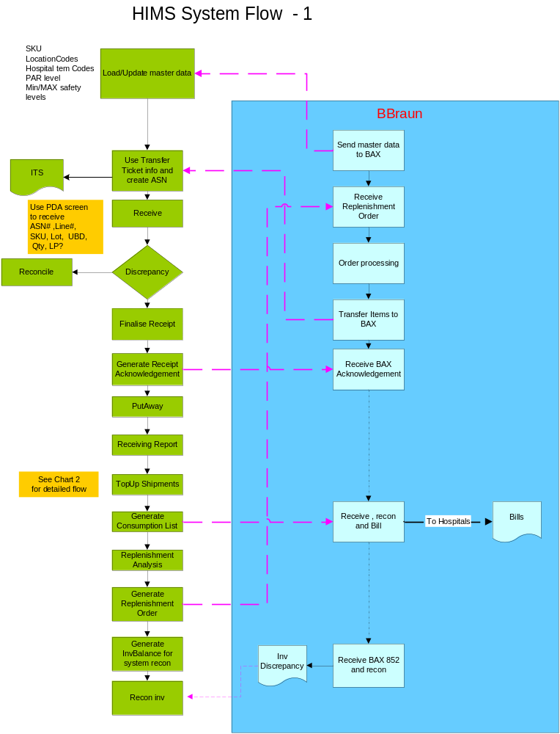
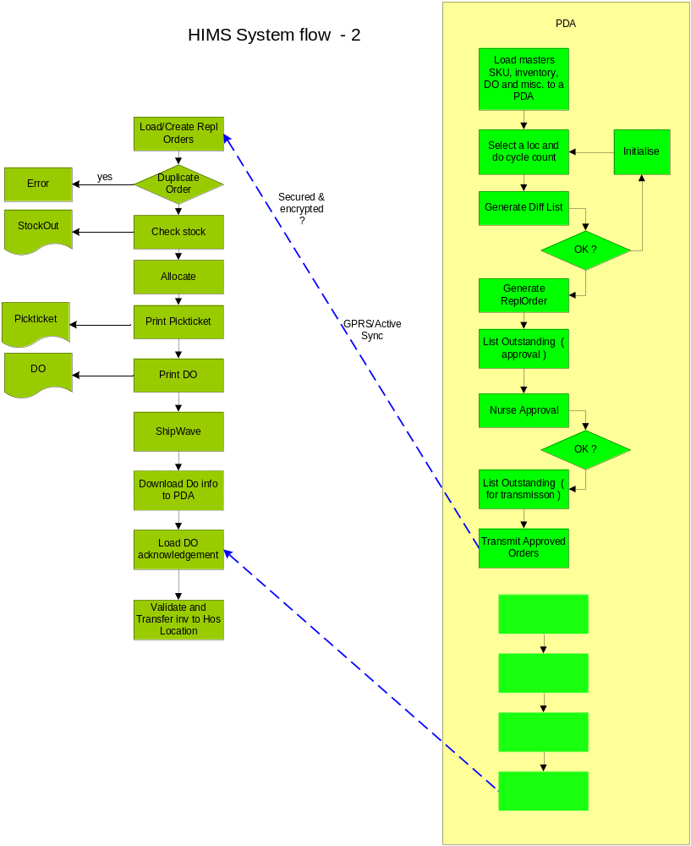

HIMS Functions
The application could be separated into following 5 major modules as they may require different approaches.

- HIMS Web Application 2. PDA Module
- Backend (DB) Configurations 4. Interfaces

5. Reports

Functional Overview

WebModule

PDA
Backend Configuration

Reports
H I M S

Admin

- MasterMaintenance
- CycleCount
- Receipt
- TopUpmanagement
- Replenishment
- Billing
- SLIM interface

- DataLoad
- CycleCount
- Reports
- DOConfirm
- DOSign
- DataUpload
- TopUp List

Masters setup
- Storer
- SKU
- Location
- Counters
Configurations
- Receipt
- Allocation
- Shipping
- Transfers
- Adjustment

Interfaces
-----------------------

SKU, ItemCodes TransferTicket

DO

Replenishment

InvBalance

- ForecastAnalysis

- Receipts

( WH , hospitals)

- PutAwayInfo

- CycleCountdetails

- ConsumptionLists

- Fast/Slow moving

- Expiry items

- Exceptions

- KPI reports

1. HIMS Web Application

1.1 Admin
Password, Changes, Security functions an Authorisations.

Masters maintanence screens

Some GUI screens for the users to view and modify certain fields of master files

- SKU master ( SKU table ) .
Web based screen to see the important fields like SKU, Descr,PackSize, Hospital Codes, Min/max qty.

- SKU vs Hospital Item Codes
Initially this will act as a query screen . Based on experience, the same could be modifed to updae the data. The main fields are
SKU, Description, HospitalCode, HospitalSKU, Hospital Desc, packSize, SKU Group

- Hospital Location Codes
To edit/query the Hospital locations that will have the following fields
    - HospitalCode
    - Name
    - LocatioCode
    - LocName
    - Contacts
    - FrquencyofCount

- Price List ( ?? If bax bills )
    - HospitalCode
    - SKU
    - ItemCode
    - UOM
    - UnitCost
    - EffectiveFrom

- PAR level maintenance
    - HospitalCode
    - LocationCode
    - SKU
    - ItemCode
    - UOM
    - PARLevel
    - EffectiveFrom
    - Endedon

- Min / Max maintenance ( Can be done with the SKU maintenance if not complicated )
    - WareHouse ( ‘Mainwarehouse’,’ ReplCentre’ etc )
    - SKU
    - PackSize
    - Min
    - Max

- Contacts ( CRM )

- HospitalCode
- LocationbCode
- Contact name
- Phone
- Handphone
- emailID

- CycleCount master ( location wise frequency etc, authorised person etc)

    - HospitalCode
    - LocationCode
    - Frequency
    - AuthorisedPerson
    - Handphone
    - emailID

1.3 Receiving

Though different types business models are possible, for simplicity the following method ( based on high probability ) is only described. The sequence of programs are ASN creation, receipt of Items, PutAway and generation of receipt reports.

- Inventory from BBraun to BAX ( SAP shipments or transfers )

  - ASN data entry can be done either thru manual data entry or importing a message file. See the file format under messages.

- Receiving ( TopUp) - Inventory at the Hospital ( BAX to hospital )
  - issue - pickpack - crate DO - auto create ASN - Finalise receipt

WareHouse Receipt ( Online using WAN or a Wedge Scanner)
( This is similar to PDA dataentry screen for the same purpose )

- Load ASN details
ASN#, Bbraun TransferTicket#, Date, Remarks
SAP Line#, SKU, QtyExpected and if avaialable Lot, UBD

- Receiving Entry Screen( similar to RF )
Choose an ASN#
Enter Line# ( from ITS )
Scan SKU
Scan Lot#
Scan Qty
Scan LP
Enter UBD
Select Condition OK/or NOT
( This info will be populated into Exceed Receipt tables )

1.4 Cycle Count management

Locationwise Cycle count approval
- Qty Adjustments
- Exceptions ( errors if any due to newid or qty mismatch )

Consumption List generation

1. Upload CC result from PDA
2. Print Variance report
3. Reduce OHQ in H/Location, update Consumption report
4. Update CC master

1.5 AuditTrail/Security

- When, What and Who uploads / downloads the data into/from PDA
- Who and when does the CCAdjustments ( normally down )
- Function Specific security …Access permissions
( will be determined later )

1.6 Reports
  - Receipt Discrepancy Report
ASN#, Line#, SKU, QtyExptecd, Qty Received, QtyDiff, ASN Lot, ASN UBD, RecdLot, Recd UBD

  - Replenishment report ( for Inv fulfill to BAX , based on forecast ).
For items whose QOH < min safety stock.
ReplOrder#, Date, Line#, SKU, ReplQty

  - Alert for INV level thru safety-stock - BAX level
When ever shipping is done for a HospitalTopUp, alert the Ops team indicating that an item QOH has gone down , that needs immediate replenishment. The indication could be incorporated in the stockout report or thru an Email to all concerned.

  - Outstanding cycle count data for process
After a cyclecount, the downloaded data from PDA will reside in a temporary table in the Exceed. After a scrutiny thru the Web Application about the details and consumption, the authorised person has to approve for the reduction of Inventory. This list will show those outstanding cycle count data for processing.

  - List of locations not cycle counted ( passed due dates )
Based on the frequency of cycle count estalished for locations, this report will list those locations not cycled counted in the due date. The main info :

Hospital, Location, frequency, last date of cycle count, last due date, Days Exceeded ( due date ).

  - Transaction History for a given location with CB.
SKU, Descr, PackKey, Date of transaction, TranType, OB, TransQty, CB , Remarks

  - List of Expired Items ( location wise details )
HospitalCode, Location Code, SKU, ItemCode, Descr, Lot, UBD, Qty, TopUpdate, Expiring in nn days.

  - Non-moving items
From a given date
HospitalCode, Location Code, SKU, ItemCode, Descr, Lot, UBD, Qty, TopUpdate, LastIssueDate, Nonmoving for nn days.

  - Fast moving items
For a given period
HospitalCode, Location Code, SKU, ItemCode, Descr, PARlevel, TotalTopUpQty, TotalIssueQty, No.ofTopUps

  - Inventory reports such as
Inventory Adjustments,
Inventory Transfers ( between Hospital Locations )

  - Consumption Analysis
Various consumption details by period/hospital/location/SKUGroupwise can be extracted and analysed …User need to specify exact requirements

  - Top up Report
After every topup , the following report will be produced for each location as Hospital, Location, LastCyclecCountdate, TopupDate, ItemCode, Description, OB, TopUpQty, CB, Remarks

  - Inventory Recon List SAP vs WMS ( requires a recon program )
The inventory recon between Customer System and BAX HIMS is to be done periodically when both systems are kept at rest. Either BAX can send an 852 to Bbraun or Bbraun can send SAP inventory balance. Assuming BAX receives SAP file, the following out put can be computed.
SAP SKU, BAX SKU, Description, SAP Qty, BAXTotQty, Diff

  - Aging Report
Hospital, SKU, Descr,TotalQty, 1-15days, 16-30days, 31-60days, 61-90days, > 91days

  - KPI reports
Yet to get details.

1.7 Billing
1. Supporting reports
Yet to get details as to what are the billing components
- Interface to SLIM
Based on step 1.

2 PDA Module

Using pocket PC 2003 and .Net technologies ( or any other stable mobile software), a mobile module integrated with HIMS has to be developed to cater for the following needs. Following paragraphs describe about the functionalities required.

2.1 Admin
Login/logOut,
AutoLogout ( after n minutes )
Security on datafiles in the PDA
Define a PDA Number ( in registry ? ) for reference

2.2 Masters download
The necessary fields for the PDA master tables are identified as follows :
Before doing the processing for a given session , the data couldbe downloaded using a GPRS connection or cradle link.

Note : Before downloading check that if any previous unloaded cyclecount/repl data is there. If so warn and direct to upload or ignore the warning.
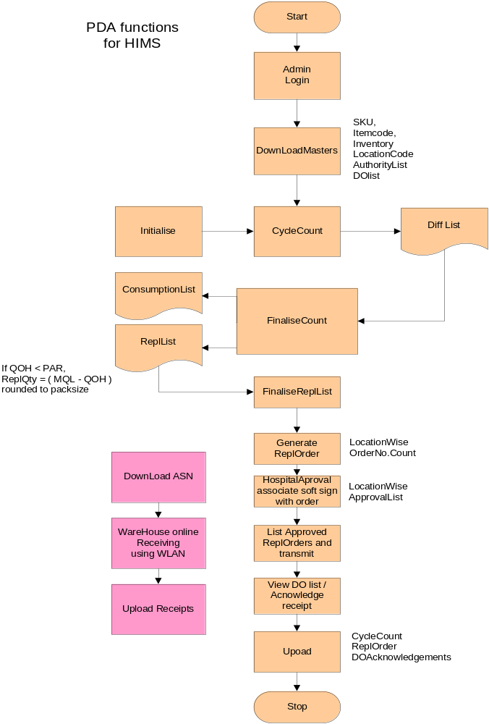

2.2.1 SKU
Purpose : For reference
SKU,
Description
HospitalCode
ItemCode
PackSize

2.2.2 Inventory
Purpose : To download the current inventory from maindb and fillup with cycc cyclecount data. If CountTime is not null, upload the data into mainDB.

Loc,
LP,
StorerKey,
SKU,
Qty,
VendorLot,
UBD,

StatusTime=@ct_date, ( ddmmyy to determine uniqueness)

PDANumber,
CountQty,
CountTime,
CountBy
Note :
If LP is present, then each scan of LP will update the CountQty = Qty else if lot is scanned, update Qty = Qty + SKU.PackSize

2.2.3 Location details
Purpose : For referece

Hospital Code
HospitalName
HospitalLocationCode
LocName

2.2.4 PAR level
Purpose : For ReplOrder creation

HospitalLocationCode
ItemCode

PARLevel/MQLQty

2.2.5 DODetail
Purpose: For topping up ( receipt at Hospital ) acknowledgement

DONumber,
LocationCode,
LineNo,
ItemCode,
QTY,
TopUpQty,
Flag ( 0 - new, 5 – Received partially, 9 – fully received )
Remarks ( if any like “Damaged”,”Wrong Item”, “ExcessQty”, “DeficitQty”)

2.2.5 ReplDetail
Purpose: For generating REPL Order and get acknowledgement

ReplKey char (10) - AutoGenerate. Loc + serial#.
ReplLineNo char (5) ,
SubLocation char (10) ,
SKU char (20) ,
ParQty int ,
QOH int ,
ReOrderPoint int ,
SysSugQty int ,
ReplQty int ,
AuthorisedByName char(100),
Authorised Signature BitMap, ( Size ? Is it in mobile DB ?)
AuthorisedTime datetime,
CycleCountDate datetime,
CycleCountBy Char(30)

2.3 Cycle Count
- Initialise ( to initialise the CycleCount qty to zero in the temp table )

- CC Data capture ( ID scan )
Scan LPs or LotNumbers For a selected Hospital Location.
( Preferable to scan LPs )
When Lot is captured, count the qty based on PackSize an item and number of lots scanned Else capture the LP and mark the sysQty = PhysicalQty.

- Report to show differences ( Loc/Hospital )
Displays SysQty , CCQty , Diff

- Consumption list for a location
Date, Location , ItemCode , QOH, Cons.Qty

- Exceptions ( newID, qty mismatch )
Loc, Item, Lp, Lot, UBD , CCQty, SysQty, Remarks
New Lot
New LP
CCQty > SysQty

2.4 Replenishment ( TopUp )
- Generate Repl order – based on the consumption qty calculated after cycle count by refering to the PAR level and StockQty.
- Nurse approval ( Soft Signature ) of the ReplOrder thru the PDA application.
- Facility to transmit approved ReplOrders using GPRS connection other than ActiveSync connection.

2.5 Data Upload
- Load cycle count data, if already not loaded. ( Prevent duplicate loads )
- Approved Replenishment upload

Note : Provision to avoid collisions like uploading the same data from 2 PDAs for the same date and location.

2.6 DO Confirmation
- Load the Do info during shipments from BAX repl centre
- Upon successful delivery at the prescribed location, confirm the DO and send the info to the HIMS via GPRS if required.

2.7 WareHouse Receipt ( Online using WAN/batch mode)
This is program would be useful to eliminate RF requirements for receiving , PutAway purposes.

- Load ASN details
ASN#, Bbraun TransferTicket#, Date, Remarks
SAP Line#, SKU, QtyExpected and if avaialable Lot, UBD

- Receiving Entry Screen( similar to RF )
Choose an ASN#
Enter Line# ( from ITS )
Scan SKU
Scan Lot#
Scan Qty
Scan LP
Enter UBD
Select Condition OK/or NOT
( This info will be populated into Exceed Receipt tables )

Reference Table may have the extracted data as
ReceiptKey ,
ReceiptLineNumber,
ExternReceiptKey,
ExternLineNo,
StorerKey,
POKey,
Sku,
DateReceived,
QtyExpected,
QtyReceived,
ToLoc,
ToId,
ConditionCode,
Lottable01,
Lottable02,
AddDate,
AddWho,
Reference1,
ExtractDate=getdate()

Misc - Capture download / upload process info ( Who, PDA, dateTime,
process, no.of records ) into a separate file for Audit Trail purposes.

3. Exceed Configurations
The following Exceed tables may need to be configured alongwith the required stored procedures and trigger programs. There will be some additional tables created for HIMS purpose and some level of integrity checks with the Exceed masters will be added to them.

- Storer
Storekey = ‘BBRAUN’ , ‘BAX’, ‘Hospital’

- SKU master
Descr, PackKey, min,max,reorderpoint, redorderqty,SKUGroup

- Locations
Locations for Warehouse as well as Hopital
Facility - WareHouse, Hospital
This may be linked with HIMS_Locations table for additional info.

- PO ? ( requirement not known at this moment )

- Receipt (upon receiving )
- Lottable01 – MfgLot# and Lottable02 for UBD.

- Adjustments (Cycle Count )

- Allocation
- FE & FIFO

4. Replenishment
This module is for Topping up of Hospital Locations. After a cycle count , repl order will be generated for a location and gets approved by authorised hospital staff. The data resided in PDA which will be transmitted using GPRS to the main database and kept in a temporary ReplTable. From Web screen, view the contents and create an SO based on the Repl Order for the shipment process. The steps are as follows.

- Create SO based on Replenishment Order
- Consolidate SOs for a Hospital ( if required )
- Print a StockOut report
- Allocate and print allocation failure report if any.
- Print pick ticket , pick and pack.
- Print DO for individual locations.
- Load Dodetails into PDA
- Ship Wave: Down Qty for BAX, generate exception on items going below safety level for top up from Bbraun

Note : Change status to ‘5’ as picked when inventory leaves hospitals.
Upon receiving acnkowledgement, update status to ‘9’. This may be
necessary if shipped items comes back to warehouse for some reason.

- Up load DO acknowledgement from PDA.
- Receive Do inventory items into corrsponding Hospital Locations.

5. Billing

There are a few biiling requirements. As full details are not known at this point, this chapter will be updated after conducting workshops.

- Generate Invoices based on approved consumptions
- Interface with SLIM

6. Messaging

The following messages ( thru any media like email , ftp server etc ) may be possible and will help to reduce a lot of manual data entries & data inconsistencies. Details of formats could be worked out later when necessary.

Bbraun

( SAP )

BAX

( HIMS )
Consumption List / DO

HOSPITALS
BAX Replenishment Order

TopUp Info

Inventory balance

Inven.bal

Consumption

HospitalItemCodes

PAR Level

ItemCodes

SKU

Transfer Ticket

Min/Max Level

Location/Clinic codes

Possible message flows

6.1 BBRaun to BAX

6.1.1 SKU
- SKU
- Descr
- PackSize
- SKUGroup
- Min/Max
- HasExpiry
- UOM
- Flag --- ( marketing items , obsolete, Blocked etc.)

6.1.2 HospitalItemCodes
- SKU
- HospitalCode
- HospitalItemCode
- HospitalGroupCode
- HopitalDescr
- UOM

6.1.3 Transfer Ticket
- SAP SO Number
- SAP Pickticket Number
- BAX replNumber
- OrderDate
- OrderLineno
- ItemCode
- ShipQty
- Lotnumber
- UBD

6.1.4 Min/Max Level
- Plant
- SKU
- PackSize
- MinQty
- MaxQty
- MinOrderQty

6.1.5 Price Lists ( if required )
- SKU
- SKUGroup
- UOM
- PackSize
- UntOfPrice
- CurrencyCode
- EffectiveFromDate
- EffectiveToDate

6.1.6 LocationCodes/Clinic codes
- HopitalCode
- Name
- LocationCode
- LocationName
- CycleCountFrequency
- Contacts

6. 2 BAX --> BBraun

6.2.1 Consumption List
- Date of Count
- Location
- SKU
- ItemCode
- PARLevel
- ConsumptionQty
- Rate ???

6.2.2 DO
- Date
- BAXDO Number ( InvoiceNumber )
- TopUpOrder Number
- ApprovedDate
- ItemCode
- PARLevel
- TopUpQty

6.2.3 Inventory Balance
- DateTime
- HospitalCode
- LocationCode
- ItemCode
- Description
- PackSize
- QOH
- QtyAtWareHouse
- QtyOutsideWareHouse
- Lot
- UBD

6.2.4 BAX Replenishment Order
    - BAXReplOrderNumber
    - ReplOrderDate
    - ReplLineNumber
    - SKU
    - Description
    - PackSize
    - ReplQty

6.3 BAX --> Hospital ( ? )

6.3.1 Consumption List
- Date of Count
- Location
- SKU
- ItemCode
- PARLevel
- ConsumptionQty
- Rate ???

6.3.2 Inventory balance ( only for a givenHospital )
- DateTime
- HospitalCode
- LocationCode
- ItemCode
- Description
- PackSize
- QtyAtLocation
- Lot
- UBD

6.3.3 TopUp info
- BAXDONumber
- TopUpReplNumber
- LineNum
- ItemCode
- ItemDescription
- PARLevel
- RequestQty
- ToppedUpQty

6.4 Hospital → BAX ( ? )

6.4.1 PAR level
- HospitalCode
- LocationCode
- ItemCode
- Description
- PARLevel

6.4.2 ItemCodes ( Verify who will provide this info … Bbraun or Hospitals ?)
    - SKU
    - Description
    - ItemCode
    - ItemDescription

7. Assumptions
Any requirement regarding a business application may not be known exactly by any individual at a given point during the start of a project. Also due to probabilities and complexities of models, we need to assume certain logics so as to design a more suitable application within the short time frame. Based on the few interactions, the following assumptions are listed for later reference. These are need to be approved by stakeholders before starting actual developments.

1. One TopUp Order per location ( one single order will not cover a whole hospital or mutiple locations)

- BAX LP will be issued to every box ( minimum issue qty ) during receiving and an association will be made to the MfgLot and UBD info.

- CCR will scan LP during cyclecounts at the Hospitals.

- If LP is not available, then LotNumber will be scanned. But hard to detect duplicats
- scanning of the same item. May be prone for lot of errors in all the processes.

- When delivered in pallets, a pallet may contain different lot numbers of the same item.

- Lot number is unique among itemcodes.

- All issues would be in mutiples of packsize.

- Each item that are issued will have a barcoded Lot# and a UBD info.

- If CycleCount Qty < SysQty, the diff is to be treated as TopUpconsumedQty.

- In case of out of stock of a particular item in a location, nurses wont take it from a neighbour location. They may order it from Pharmacy or at the worst case, borrow it from neighbour for an one to one exchange basis.

8 References
Please refer to the following documents to understand the business flow.

1. Business Narrative - Yet to be done
2. Bbraun SOW for IT development – Yet to be done

02/04/2003
- Pasting of LPs during shipping where required.
- Apr 6 to 9 Workshop

- July takeover

9 Table Schema
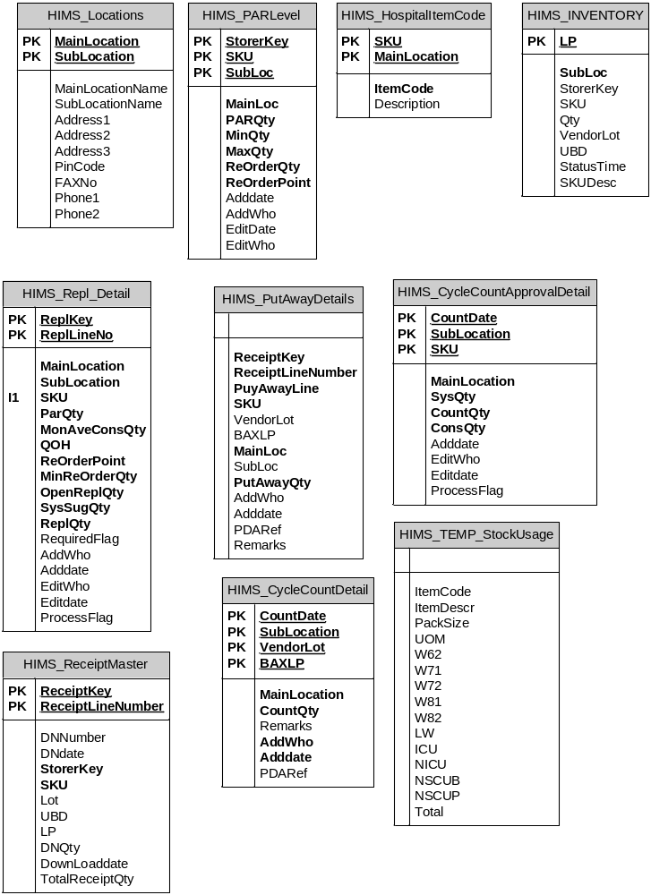

9.1 Table structures

HIMS Tables ( Other than Exceed )

9.1.1 HIMS_ReceiptMaster
Use : To get all the Open DN details… once an ASN / Receipt created based on SAP data or Hardcopy the Receipt and Receiptetail table will have the data. This table has to be copied to the PDA for PutAway of goods. This will be required if there is no BAX Repl centre or WareHouse. i.e Direct delivery from Bbraun to Hospitals.

(
[DNNumber] [char] (20) NULL ,
[DNdate] [datetime] NULL ,
[ReceiptKey] [char] (10) NOT NULL ,
[ReceiptLineNumber] [char] (5) NOT NULL ,
[StorerKey] [char] (20) NOT NULL ,
[SKU] [char] (30) NOT NULL ,
[Lot] [char] (10) NULL ,
[UBD] [char] (8) NULL ,
[LP] [char] (10) NULL ,
[DNQty] [int] NULL ,
[DownLoaddate] [datetime] NULL ,
[TotalReceiptQty] [int] NULL
)

9.1.2 HIMS_PutAwayDetails

Use : To get all the putaway records in the PDA. It will refer to the Master table for validations during data capture . This may not be required, if ReplCentre is not set up.

(
ReceiptKey char (10) NOT NULL ,
ReceiptLineNumber char (5) NOT NULL ,
PuyAwayLine char (5) NOT NULL ,
SKU char (30) NOT NULL ,
VendorLot char (30) NULL ,
BAXLP char (10) NULL ,
MainLoc char (10) NOT NULL ,
SubLoc char (10) NULL ,
PutAwayQty int NOT NULL ,
AddWho char (10) NULL ,
Adddate datetime NULL ,
PDARef char (10) NULL ,
Remarks char (30) NULL
)

9.1.3 HIMS_Locations

Use : To hold Hospital Location Info

(
[MainLocation] [char] (10) NOT NULL ,
[SubLocation] [char] (10) NOT NULL ,
[MainLocationName] [char] (100) NULL ,
[SubLocationName] [char] (60) NULL ,
[Address1] [char] (30) NULL ,
[Address2] [char] (30) NULL ,
[Address3] [char] (30) NULL ,
[PinCode] [char] (10) NULL ,
[FAXNo] [char] (20) NULL ,
[Phone1] [char] (10) NULL ,
[Phone2] [char] (10) NULL
)

9.1.4 HIMS_CycleCountDetail

Use : To capture all CycleCount data from the Locations.

[MainLocation] [char] (10) NOT NULL ,
CountDate char ( 8 ) ( as YYYYMMDD )
[SubLocation] [char] (10) NOT NULL ,
[VendorLot] [char] (20) NOT NULL ,
[BAXLP] [char] (10) NOT NULL ,
[CountQty] [int] NOT NULL ,
[Remarks] [char] (10) NULL ,
[AddWho] [char] (10) NULL ,
[Adddate] [datetime] NULL ,
[PDARef] [char] (10) NULL

9.1.5 HIMS_PARLevel

Use : To mainatain PAR level for each SKU locationwise/ or hopitalwise.

(
[StorerKey] [char] (10) NOT NULL ,
[SKU] [char] (20) NOT NULL ,
[MainLoc] [char] (10) NOT NULL ,
[SubLoc] [char] (10) NOT NULL ,
[PARQty] [int] NOT NULL ,
[MinQty] [int] NOT NULL ,
[MaxQty] [int] NOT NULL ,
[ReOrderQty] [int] NOT NULL ,
[Adddate] [datetime] NULL ,
[AddWho] [char] (10) NULL ,
[EditDate] [datetime] NULL ,
[EditWho] [char] (10) NULL

Assumptions for later discussions:
- Same SKU may not be in VMI and Consignement
- Storerkey = ‘BBRAUN’. Cant use Storerkey for Hospitals.
Just codify Loc accodingly as Example KKWH-OT01
Otherwise for each hospital/clinic the SKU master
has to be duplicated.

Note : The tables needed for PDA is furnished in the PDA section

9.1.6 HIMS_CycleCountApprovalDetail

Purpose : After downloading the CycleCount data into the CycleCountdetail, data will be checked and approved so that actual consumption qty can be determined/manipulated thru a WebScreen. If this has been already approved by the Nurse then , directly insert the approved qty then detect the inventory at the locations.
MainLocation char (10) ,
CountDate char (10) ,
SubLocation char (10) ,
SKU char (20) ,
SysQty int NOT NULL ,
CountQty int NOT NULL ,
ConsQty int NOT NULL ,
Adddate datetime NULL ,
EditWho char (10) ,
Editdate datetime NULL ,
ProcessFlag char (1)

9.1.7 HIMS_HospitalItemCode
Purpose : To stand as a cross reference table for converting customer SKU into Hopital Items copdes and vice versa.

SKU char (20) ,
MainLocation char (10) ,
ItemCode char (20) ,
Description char (250)

9.1.8 HIMS_Inventory
Purpose : To download current inventory into the PDA after extracting.

SubLoc nchar (10) ,
LP nchar (20) ,
StorerKey nchar (15) ,
SKU nchar (20) ,
Qty int NULL ,
VendorLot nchar (20) ,
UBD nchar (18) ,
StatusTime datetime NULL ,
SKUDesc nvarchar (60)

HIMS_Repl_Detail
Purpose : To receive the PDA repl data those got approved.
ReplKey char (10) ,
ReplLineNo char (5) ,
SubLocation char (10) ,
SKU char (20) ,
ParQty int ,
QOH int ,
ReOrderPoint int ,
SysSugQty int ,
ReplQty int ,
AuthorisedByName char(100),
Authorised Signature BitMap,
AuthorisedTime datetime
AddWho char (10) ,
Adddate datetime ,
EditWho char (10) ,
Editdate datetime ,
ProcessFlag char (1) ( ‘0’ - New,
‘5’ – Approved,
‘8’ processed partially,
‘9’ – Fully processed )

HIMS_Repl_Detail

Purpose: For receiving acknowledged DOs from PDA.

DONumber,
LocationCode,
LineNo,
ItemCode,
QTY,
TopUpQty,
Flag ( 0 - new, 5 – Received partially, 9 – fully received )
Remarks ( if any like “Damaged”,”Wrong Item”, “ExcessQty”, “DeficitQty”)

